

**Research & Vehicle Technology**

**“Infotainment Systems Product Development”**

**Feature – Ambient Lighting & IVI Welcome Animation Subsystem Part Specific Specification (SPSS)**

Draft Version 3.0

**UNCONTROLLED COPY IF PRINTED**

**Version Date: Oct 12th, 2021**

**FORD CONFIDENTIALF**

# Functional Definition

## Ambient Lighting Dynamic illumination& IVI Welcome animation work in coordination

### Definition

Welcome stage:

When unlock the vehicle and open any door, the front and rear door panel ambient lightings shall work with IVI Welcome animation and start dynamic illumination and the APIM_CIM animation and Ambient lighting dynamic illumination shall continue when close any door.

Farewell stage:

When Ignition off, and open any front door, the front door/rear door Ambient Lightings start dynamic illumination and work with IVI farewell animation. And Ambient lighting dynamic illumination and IVI farewell animation shall continue when close any door.

### Use Cases

#### VS-UC-REQ-340548/A-Ambient lightings dynamic illumination work with IVI welcome animation.

|  |  |  |
| --- | --- | --- |
| **Actors** |  | User |
| **Pre-conditions** |  | Lincoln Embrace is not inhibited  Vehicle is locked and ignition is off |
| **Main flow** | M1 | vehicle is unlocked using either a Key-Fob, PAAK. Door Keypad code, or any other means from the exterior of the vehicle while the ignition is OFF. |
| M2 | Open any door |
| M3 | IVI starts playing welcome animation |
| M4 | When IVI welcome animation arrive to 135th frame, front door/rear door Ambient lightings start fluent illumination over a period of xxs seconds and then keep breathe illumination. |
| M5 | IVI display turn off and front door/rear door Ambient lightings fade off form current intensity within 4s after door ajar 25s. |
| M6 | Close all door |
| M7 | IVI display remain off and front door/rear Ambient lightings fade on from 0 to 100% intensity during a period of 3s. |
| M8 | IVI display remain off and front door/rear Ambient lightings fade off from 100% to 0 intensity during period of 4s after all door closed 25s. |
| M9 | Ignition on/start, IVI display turn on and front door/rear Ambient lightings fade on from 0 to the intensity saved by customer or SDM color within 3s. |
| **Alternative Flow 1** | A3.1 | Close all door within 25s after door ajar |
| A4.1 | Continue from M3 or M4 |
| A5.1 | IVI display turn off and front door/rear door Ambient lightings fade off from current intensity to 0 intensity within 4s after door closed 25s. |
|  | A6.1 | Ignition on/start, IVI display turn on and IP/front door/rear Ambient lightings fade on from 0 to the intensity saved by customer or SDM color within 3s. |

#### VS-UC-REQ-340548/A-Ambient lightings dynamic illumination work with IVI farewell animation.

|  |  |  |
| --- | --- | --- |
| **Actors** |  | User |
| **Pre-conditions** |  | Lincoln Embrace is not inhibited  All door closed and ignition on  Ambient lighting remains on |
| **Main flow** | M1 | Ignition transitioned to off |
| M2 | Ambient lighting fade off to 10% intensity |
| M2 | Open any front door |
| M3 | Ambient Lighting start dynamic illumination |
| M4 | When Ambient Lighting front door LED bar fade off, IVI start farewell animation. |
| M5 | Ambient Lighting remain off and IVI is off after farewell animation |
| M6 | Close all door after door ajar 25s |
| M7 | Ambient Lighting remain off and IVI remain off |
| M8 | Ambient Lighting remain off and IVI remain off after door closed 25s |
| M9 | Lock vehicle |
| M10 | Ambient Lighting remain off and IVI remain off |
| **Alternative Flow 1** | A3.1 | Close all door within 25s after door ajar |
| A4.1 | Continue from M3 ,M4,M5 |
| A5.1 | Ambient Lighting remain off and IVI remain off after door closed 25s |
|  | A6.1 | Lock vehicle |
|  | A7.1 | Ambient Lighting remain off and IVI remain off |
| Alternative Flow 2 | B3.1 | Close all door within 25s after door ajar |
| B4.1 | Continue from M3 ,M4,M5 |
| B5.1 | Lock vehicle within 25s after close all door |
| B6.1 | Ambient Lighting fade off, IVI gets off |

### Interface Requirements

#### AmbientLgt_Dyn_Rq

Message Type: Request

Source Network: private CAN

Signal Transmit Strategy: cyclic

Signal Transmit Cycle 50ms

Note1: Request signal from APIM_CIM to AUX.

|  |  |  |  |
| --- | --- | --- | --- |
| **Logical Signal Name** | **Literals** | **Value** | **Description** |
| AmbientLgt_Dyn_Rq | Null | 0x0 | Default value. |
| Type1 | 0x1 | The first trigger to start Ambient lighting dynamic illumination |
| Type2 | 0x2 | The second trigger to start Ambient lighting dynamic illumination |
| Type3 | 0x3 | NotUsed_1 |

#### APIM_FW_Animation_Rq

Message Type: Request

Source Network: private CAN

Signal Transmit Strategy: cyclic

Signal Transmit Cycle Time:50ms

Note1: Request signal from AUX to APIM_CIM

|  |  |  |  |
| --- | --- | --- | --- |
| **Logical Signal Name** | **Literals** | **Value** | **Description** |
| APIM_FW_Animation_Rq | Null | 0x0 | Default value. |
| Type1 | 0x1 | The trigger to start IVI farewell animation |
| Type2 | 0x2 | NotUsed_1 |
| Type3 | 0x3 | NotUsed_2 |

#### AUX_AmbientLgt_Dyn_Rq

Message Type:Request

Source Network: LIN

Signal Transmit Strategy: Periodic

Signal Transmit Cycle Time:50ms

Note: request signal from AUX to Ambient Lighting

|  |  |  |  |
| --- | --- | --- | --- |
| **Logical Signal Name** | **Literals** | **Value** | **Description** |
| AUX_AmbientLgt_Dyn_Rq | Null | 0x0 | Default value. |
| Type1 | 0x1 | The first trigger to start Ambient lighting dynamic illumination |
| Type2 | 0x2 | NotUsed_1 |
| Type3 | 0x3 | NotUsed_2 |

#### DOOR_AUX_APIM_FW_Animation_Rq

Message Type:Request

Source Network: LIN

Signal Transmit Strategy: Periodic

Signal Transmit Cycle Time: 200ms

Note: request signal from Ambient Lighting to AUX

|  |  |  |  |
| --- | --- | --- | --- |
| **Logical Signal Name** | **Literals** | **Value** | **Description** |
| DOOR_AUX_APIM_FW_Animation_Rq | Null | 0x0 | Default value. |
| Type1 | 0x1 | The trigger to start IVI farewell animation |
| Type2 | 0x2 | NotUsed_1 |
| Type3 | 0x3 | NotUsed_2 |

### Requirements

#### IVI welcome animation & Ambient lightings dynamic illumination functional requirement

The AmbientLgt_Dyn_Rq is transferred by private CAN from APIM_CIM to AUX, and AUX convert the signal to LIN signal: AUX_AmbientLgt_Dyn_Rq to Ambient lighting modules. Ambient light modules include front door, rear door ambient lighting modules.

The DOOR_AUX_APIM_FW_Animation _Rq is transferred by LIN from Ambient Lightings to AUX, and AUX convert the signal to private CAN signal: APIM_FW_Animation _Rq to APIM_CIM.

#### APIM_CIM requirements

Welcome stage:

APIM_CIM shall send “AmbientLgt_Dyn_Rq” with value 0x1 for synchronization with front door/rear door ambient lightings’ dynamic illumination when IVI welcome animation arrive to 135th frame.

Note: when arrive to 135th frame, APIM_CIM shall send out the signal with value 0x1(keep 150mills), then the value of this signal will return to default value 0x0.

Configurations:

APIM_CIM shall define a configuration :,which is called “Ambient Lighting coordination”.

The value of 0x1 indicate to enable “AmbientLgt_Dyn_Rq” signal. The value of 0x0 indicates to disable the signal.

When the configuration of “Ambient Lighting coordination” is 0x1, the default value of “AmbientLgt_Dyn_Rq” would be 0x0.

|  |  |  |
| --- | --- | --- |
|  | Ambient Lighting coordination | Description |
| 1 | 0x0(default) | disable “AmbientLgt_Dyn_Rq” signal |
| 2 | 0x1 | enable “AmbientLgt_Dyn_Rq” signal |

APIM_CIM shall define a configuration with bit of DE00 byte9-byte10 which is called “Ambient lighting trigger frame”

, and when set as xxth frame, means APIM send the “AmbientLgt_Dyn_Rq” signal with 0x1 at xxth frame. The value scope is from 0~65535(resolution:1)

Default value:135

Note: the configuration is available only when Ambient Lighting coordination=0x1.

|  |  |  |
| --- | --- | --- |
|  | Ambient lighting trigger frame | Description |
| 1 | 0x0 | Send “AmbientLgt_Dyn_Rq” signal with 0x1 at 0th frame |
| … | … | … |
| 65536 | 65535 | Send “AmbientLgt_Dyn_Rq” signal with 0x1 at 65535th frame |

Farewell stage:

When APIM_CIM receive the signal APIM_FW_Animation _Rq with value 0x1 from AUX, APIM_CIM delay xxs(need to calibration) to start farewell animation.

Note1：when door transitioned to ajar in farewell stage and APIM_CIM does not receive the signal APIM_FW_Animation _Rq with value 0x1 over triggerdelaytimer(need to calibration), APIM_CIM shall start farewell animation.

Note2：when receive the trigger signal from AUX, display screen shall delay fwdelaytimer to start the farewell animation and fwdelaytimer can be configurable to make the sequential animation more fluently.

Configurations:

APIM_CDC shall define a configuration with bit of xxxx which is called “farewell animation_ Ambient lighting”, and when this configuration set as 0x1, APIM shall receive the APIM_FW_Animation _Rq from ambient lighting and active triggerdelaytimer.

|  |  |  |
| --- | --- | --- |
|  | farewell animation_ Ambient lighting | Description |
| 1 | 0x0(default) | Farewell animation has no coordination with ambient lighting |
| 2 | 0x1 | Farewell animation has coordination with ambient lighting |

APIM_CDC shall define a configuration with bit of xxxx which is called “triggerdelaytimer”. The value scope is from 0-65535(resolution:1, unit: ms)

|  |  |  |
| --- | --- | --- |
|  | triggerdelaytimer | Description |
| 1 | 0 | start farewell animation if doesn’t receive the signal: *farewell animation_ Ambient lighting with value of 0x1 over* 0s after door open in farewell stage |
| 2 | … |  |
| 3 | 65535 | start farewell animation if doesn’t receive the signal: *farewell animation_ Ambient lighting with value of 0x1 over* 65.535s after door open in farewell stage |

APIM_CDC shall define a configuration with bit of xxxx which is called “fwdelaytimer”. The value scope is from 0-255(resolution:10, unit: ms)

|  |  |  |
| --- | --- | --- |
|  | fwdelaytimer | Description |
| 1 | 0 | Delay 0s to start farewell animation when receive APIM_FW_Animation _Rq with 0x1 |
| 2 | … |  |
| 3 | 255 | Delay 2.55s to start farewell animation when receive APIM_FW_Animation _Rq with 0x1 |

Decision table

|  |  |  |  |  |
| --- | --- | --- | --- | --- |
|  |  |  |  | LE_WF_Welcome/Farewell Display |
| VehWlcmFrwl_D_Stat | VehWlcmFrwlMde_D_Stat | APIM_FW_Animation _Rq | triggerdelaytimer | Welcome/Farewell Animation Request |
| WELCOME | APPROACH | Don’t care | Don’t care | OFF(but Wake-up display) |
| ILLUMINATEDENTRY | Don’t care | Don’t care | OFF - But Wake-up Display (Or Stay Awake, If Already Awake) |
| COURTESYLIGHTINGALL | Don’t care | Don’t care | ON - Start Welcome Animation |
| COURTESYLIGHTINGDELAYALL | Don’t care | Don’t care | ON - (And Continue Welcome Animation Until End) |
| COURTESYLIGHTINGEXTENDED | Don’t care | Don’t care | Off (stay awake) |
| COURTESYLIGHTINGDELAYEXT | Don’t care | Don’t care | Off (stay awake) |
| NULL | Don’t care | Don’t care | Off (stay awake) |
| RUNSTART |  | Don’t care | Don’t care | ON |
| FAREWELL | ILLUMINATEDEXIT | Don’t care | Don’t care | ON |
| COURTESYLIGHTINGALL | 0x0 | <=xxs | ON |
| 0x0 | >xxs | Start Farewell animation |
| 0x0🡪0x1 | <=xxs | Start Farewell animation until end |
| Others | | Continue farewell animation or remain off |
| COURTESYLIGHTINGDELAYALL | 0x0 | <=xxs | ON |
| 0x0 | >xxs | Start Farewell animation |
| 0x0🡪0x1 | <=xxs | Start Farewell animation |
| Others | | Continue farewell animation or remain off |
| COURTESYLIGHTINGEXTENDED | Don’t care | Don’t care | Off (Sleep) |
| COURTESYLIGHTINGDELAYEXT | Don’t care | Don’t care | Off (Sleep) |
| NULL | Don’t care | Don’t care | Off (Sleep) |
| NULL | NULL | Don’t care | Don’t care | Off (Sleep) |

#### AUX requirements

Signals:

Welcome stage:

When AUX receive the “AmbientLgt_Dyn_Rq” signal, shall convert the CAN signal to LIN signal to Ambient lightings. And corresponding relationship is as below.

|  |  |
| --- | --- |
| CAN signal | LIN signal |
| AmbientLgt_Dyn_Rq | AUX_AmbientLgt_Dyn_Rq |
| 0x0 | 0x0 |
| 0x01 | 0x01 |
| 0x02 | 0x02 |

Note: When AUX does not receive the signal: AmbientLgt_Dyn_Rq, AUX shall send out the corresponding LIN signal with the last value received rather than the default value 0x0. When AUX wake up from sleeping and does not receive the signal over xxs( follow AUX requirements), the AUX will send out the default value 0x0.

Farewell stage:

When AUX receive the “DOOR_AUX_APIM_FW_Animation _Rq” signal, shall convert the LIN signal to private CAN signal to APIM_CIM. And corresponding relationship is as below.

|  |  |
| --- | --- |
| LIN signal | Private CAN signal |
| DOOR_AUX_APIM_FW_Animation_Rq | APIM_FW_Animation _Rq |
| 0x0 | 0x0 |
| 0x01 | 0x01 |
| 0x02 | 0x02 |

Note: When AUX does not receive the signal: DOOR_AUX_APIM_FW_Animation_Rq, AUX shall send out the corresponding private CAN signal with the last value transmitted rather than the default value 0x0. When AUX wake up from sleeping and does not receive the signal, the AUX will send out the default value 0x0.

#### Ambient lighting requirements

Front door/rear door Ambient Lighting shall follow below requirements.

|  |  |  |  |  |  |  |
| --- | --- | --- | --- | --- | --- | --- |
| **LIN Signals** | | | | | | **front door/rear door Ambient Lightings behavior** |
| **AUX_Wfsupertate** | **Values** | **AUX_WFsubstate** | **Values** | **Description** | **AUX_AmbientLgt_Dyn_Rq** |  |
| WELCOME | 0x1 | Approach | 0x1 | Vehicle approach was detected | Don’t care | Off |
| IllumEntry | 0x2 | Vehicle was unlocked from outside | Don’t care | Off |
| COURTESYLIGHTINGALL | 0x3 | Vehicle doors transitioned to ajar | 0x0 | Remain off and Waiting for trigger or keep dynamic illumination |
| COURTESYLIGHTINGALL | 0x3 | Vehicle doors transitioned to ajar | 0x0🡪0x1 | Start Dynamic illumination |
| COURTESYLIGHTINGALL | 0x3 | Vehicle doors transitioned to ajar | 0x1🡪0x0 | Keep Dynamic illumination |
| COURTESYLIGHTINGDELAYALL | 0x4 | Vehicle doors transitioned from ajar to all close within door ajar 25s | 0x0 | Remain off and Waiting for trigger or keep dynamic illumination |
| COURTESYLIGHTINGDELAYALL | 0x4 | Vehicle doors transitioned from ajar to all close within door ajar 25s | 0x0🡪0x1 | Start dynamic illumination |
| COURTESYLIGHTINGDELAYALL | 0x4 | Vehicle doors transitioned from ajar to all close within door ajar 25s | 0x1🡪0x0 | Keep dynamic illumination |
| COURTESYLIGHTINGEXTENDED | 0x5 | Vehicle doors transitioned to ajar above 25s | Don’t care | Fade Off or off |
| COURTESYlLIGHTINGDELAYEXT | 0x6 | Vehicle doors transitioned from ajar to all close after door ajar 25s | Don’t care | Fade on or on |
| Null | 0x0 | Time out | Don’t care | Fade off or off |
| RUNSTART | 0x3 | Don’t care | Don’t care | Ignition not off | Don’t care | In-drive setting/SDM |
| FAREWELL | 0x2 | ILLUMINATEDEXIT | 0x7 | Ignition has transitioned to off | Don’t care | Fade on or on(10%) |
| COURTESYLIGHTINGALL | 0x3 | Vehicle doors transitioned to ajar | Dynamic illumination then fade off |
| COURTESYLIGHTINGDELAYALL | 0x4 | Vehicle doors transitioned from ajar to all close within door ajar 25s | Continue Dynamic illumination then off or off |
| COURTESYLIGHTINGEXTENDED | 0x5 | Vehicle doors transitioned to ajar above 25s | Remain off |
| COURTESYlLIGHTINGDELAYEXT | 0x6 | Vehicle doors transitioned from ajar to all close after door ajar 25s | Remain off |
| Null | 0x0 | Time out | off |
| Null | 0x0 | Null | 0x0 | Vehicle locked | Don’t care | off |

Note: When Ambient Lighting front door panel first ambient lighting bar start fade off in farewell stage, shall send out the signal “DOOR_AUX_APIM_FW_Animation_Rq” with value of 0x01 to AUX module, and AUX module convert to private CAN signal “APIM_FW_Animation _Rq” to APIM to trigger APIM start the farewell animation. And when receive the AUX_WFsubstate withCOUTESYLIGHTINGALL 0x3, the value of “DOOR_AUX_APIM_FW_Animation _Rq” shall return to 0x0.

### Block Diagram

The block diagram could be referred to as below.

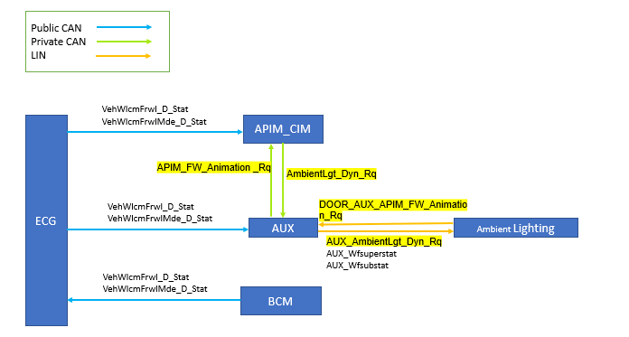

### Sequence Diagram

Welcome stage:

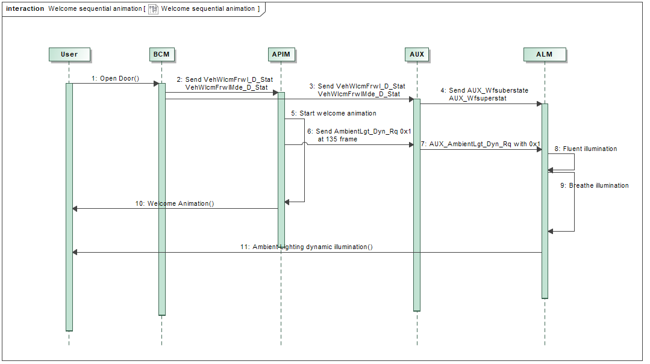

Farewell Stage:

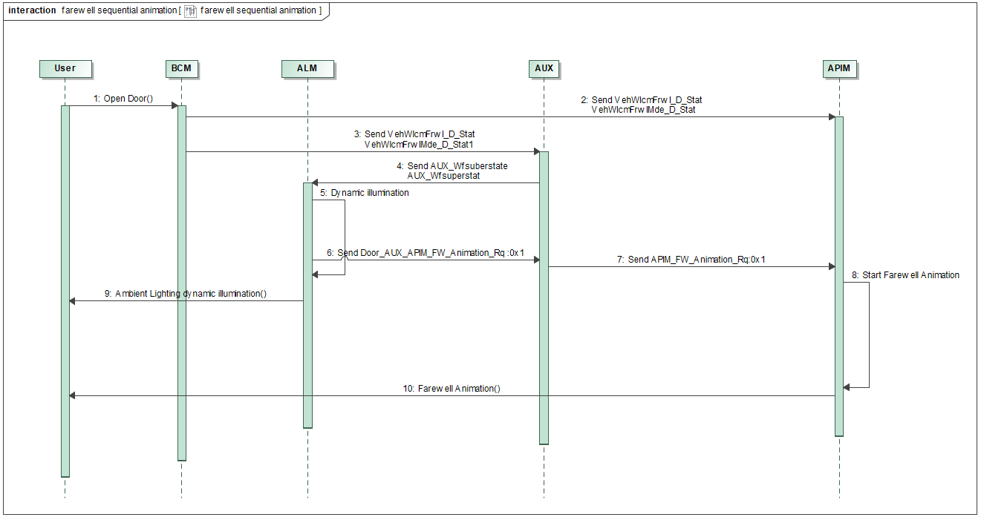

### Specific state

### If there are conflicts with feature spec: *Lincoln Embrace_v2.2.2_CDX707_updated*, shall follow this spec.

### Ambient lighting detailed performance refer to *Specification+for+functional+requirements+of+ambient+light-V1.41104*